**LAB 3 & 4:**

PROBLEM#1

Practicing with simple if condition. Execute the following program with a = 400 and b =500. Then change the value of a =500 and b = 400.

INPUT:

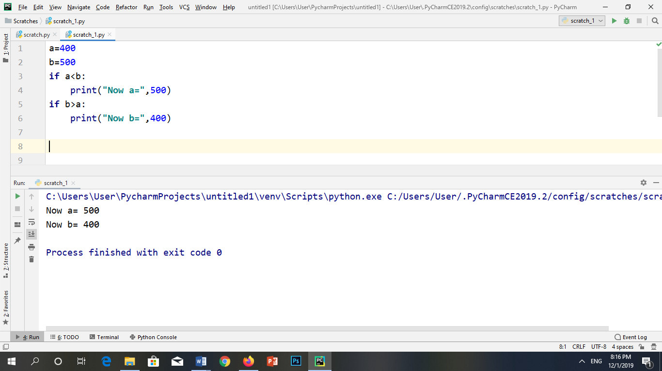

OUTPUT:



PROBLEM#2

Practicing with simple if condition if both conditions are true using AND operator.

INPUT:

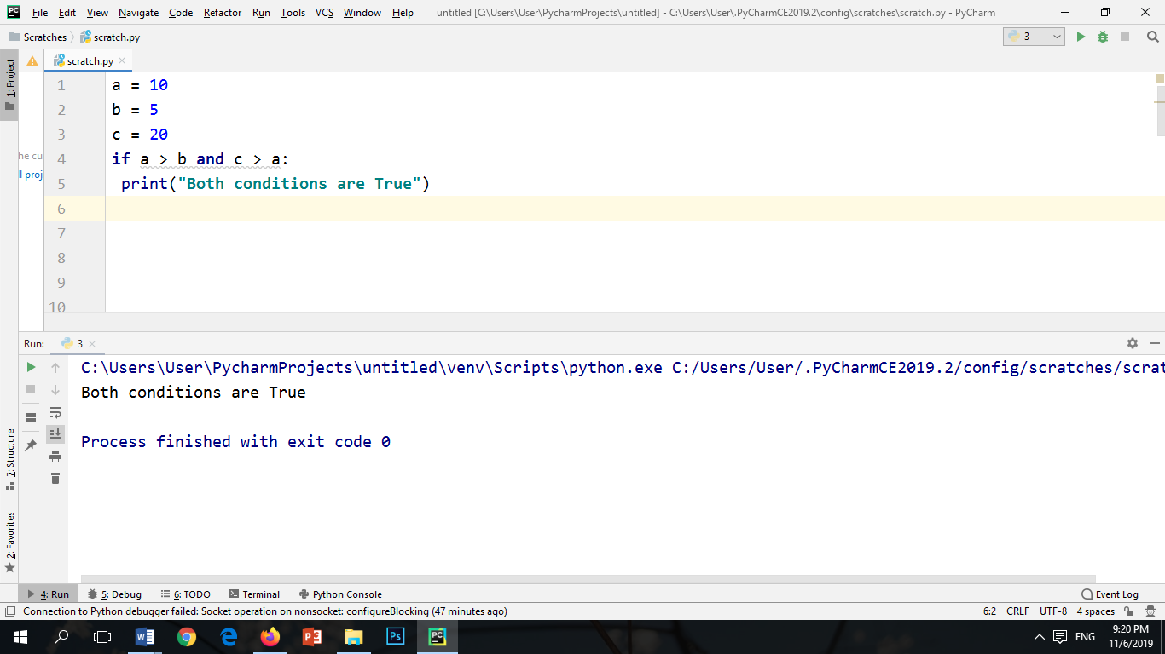

OUTPUT:



PROBLEM#3

Practicing with simple if condition if any of the condition is true using OR operator.

INPUT:

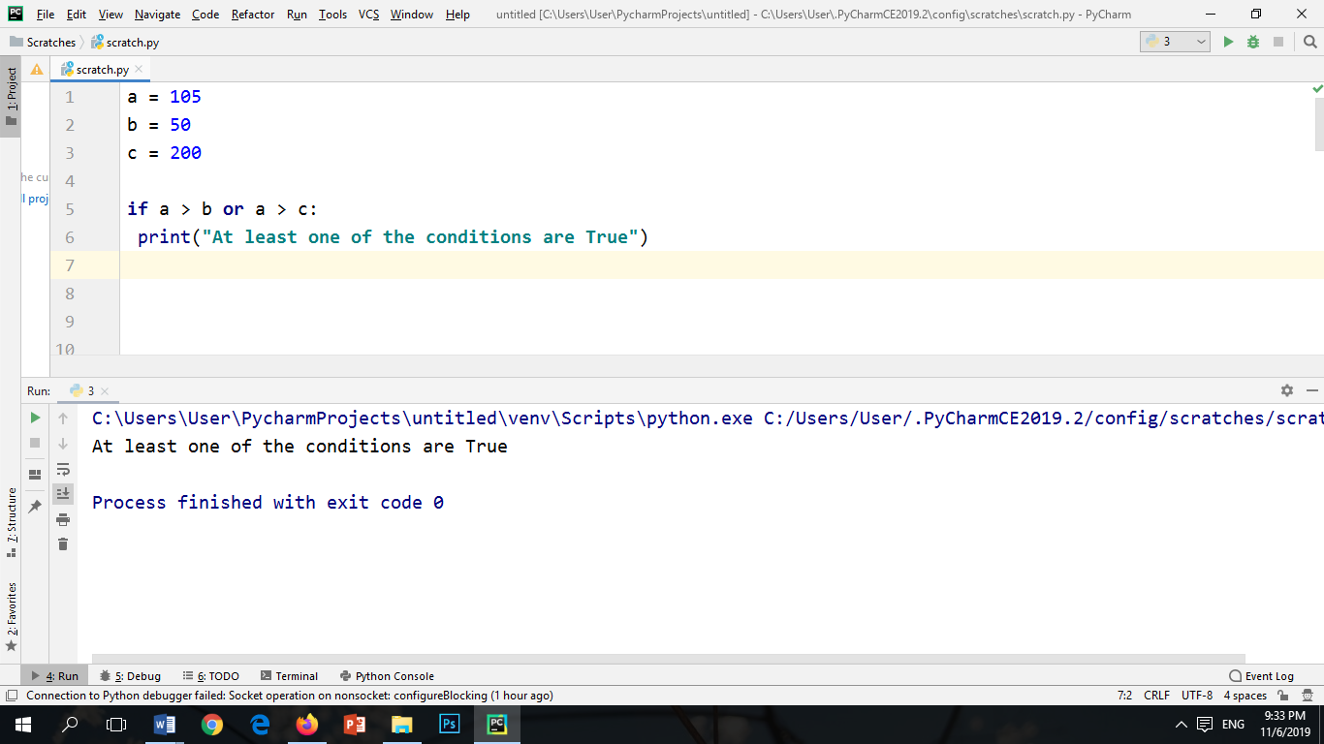

OUTPUT:



PROBLEM#4

Write a program which takes the lower limit and upper limit then find which of the number are prime number.

INPUT:

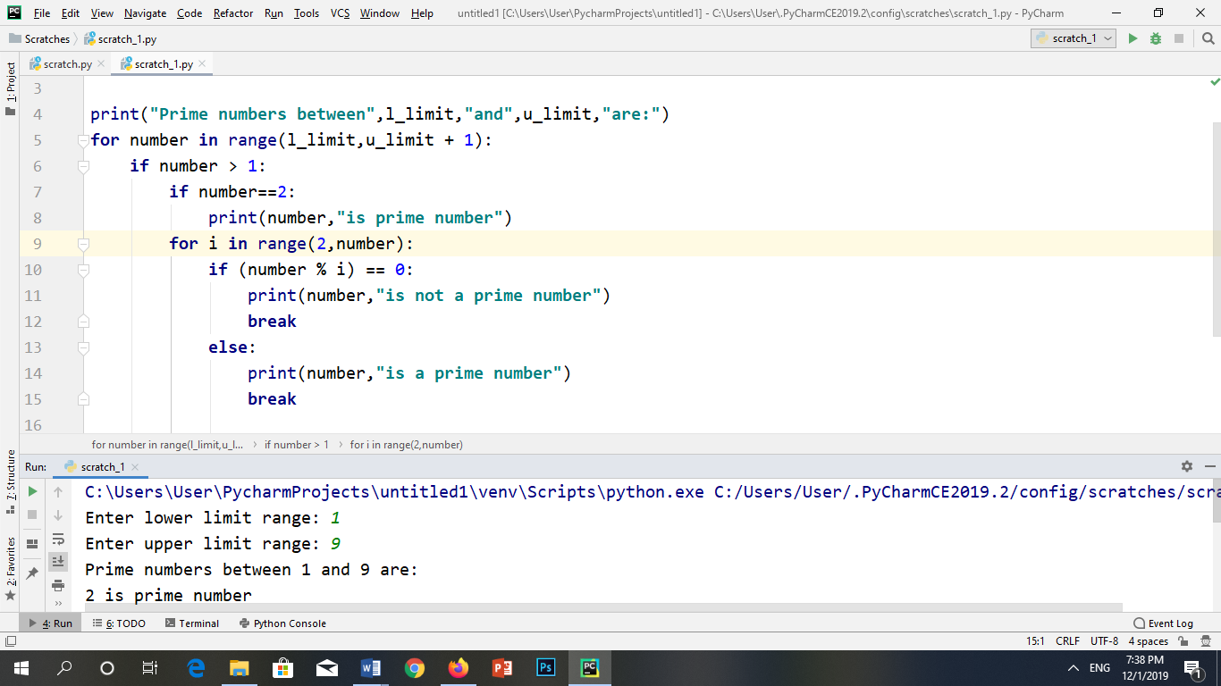

OUTPUT:

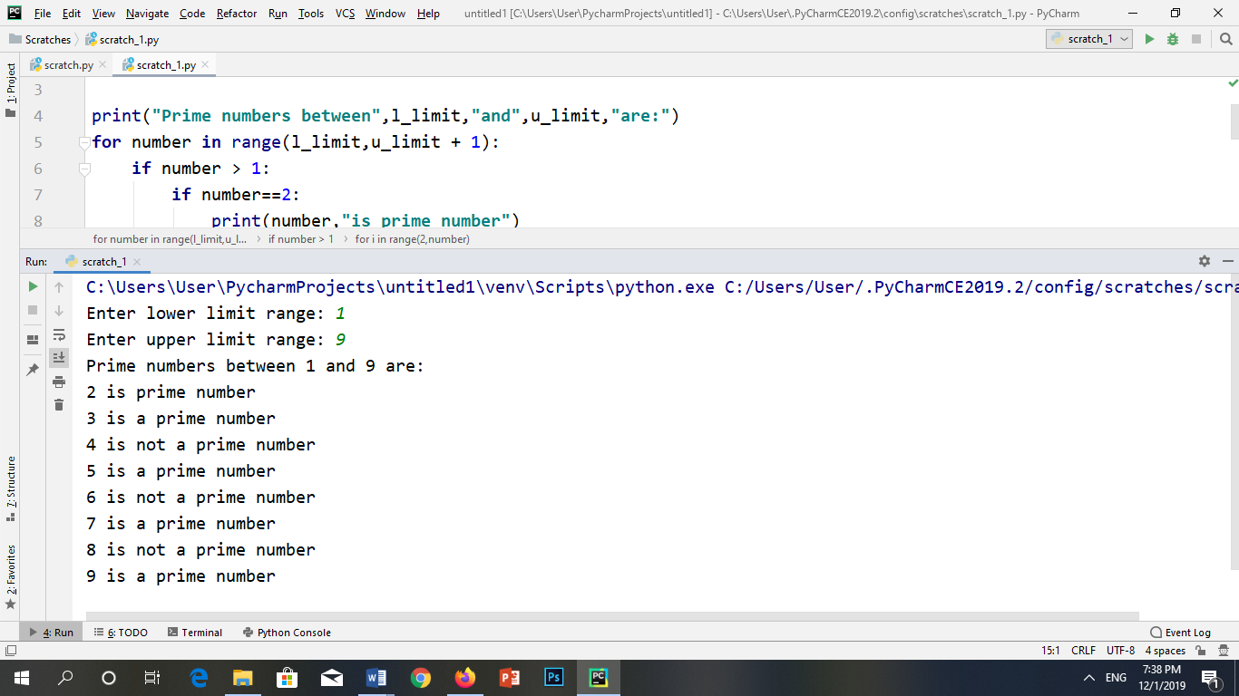

PROBLEM#5

Write a program which takes the initial and final values from the user then print the sum of all the number.

INPUT:

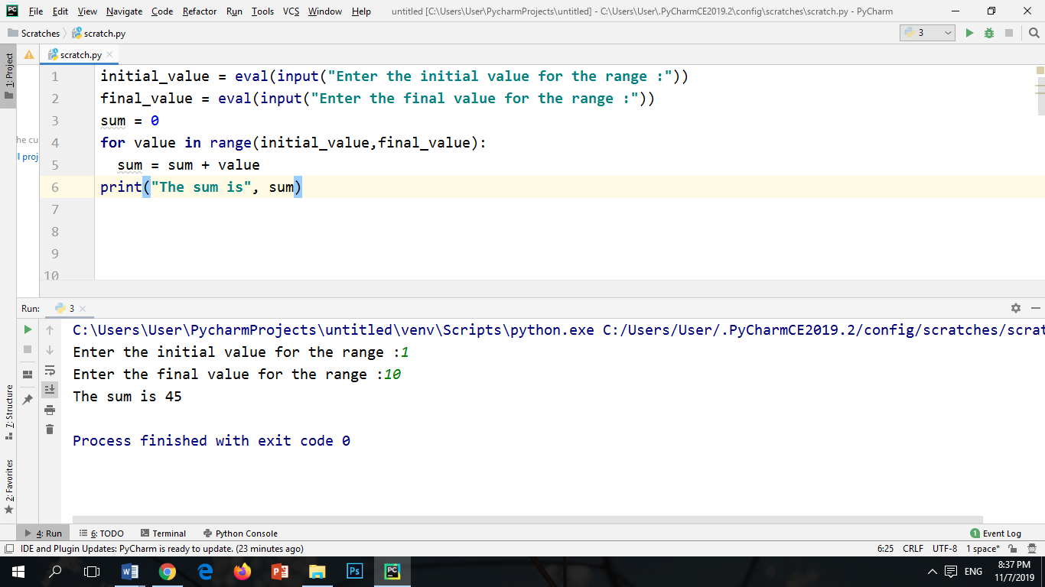

OUTPUT:



PROBLEM#6

Write a program which takes the number of rows and columns from the user and generate the values in form of list.

INPUT:

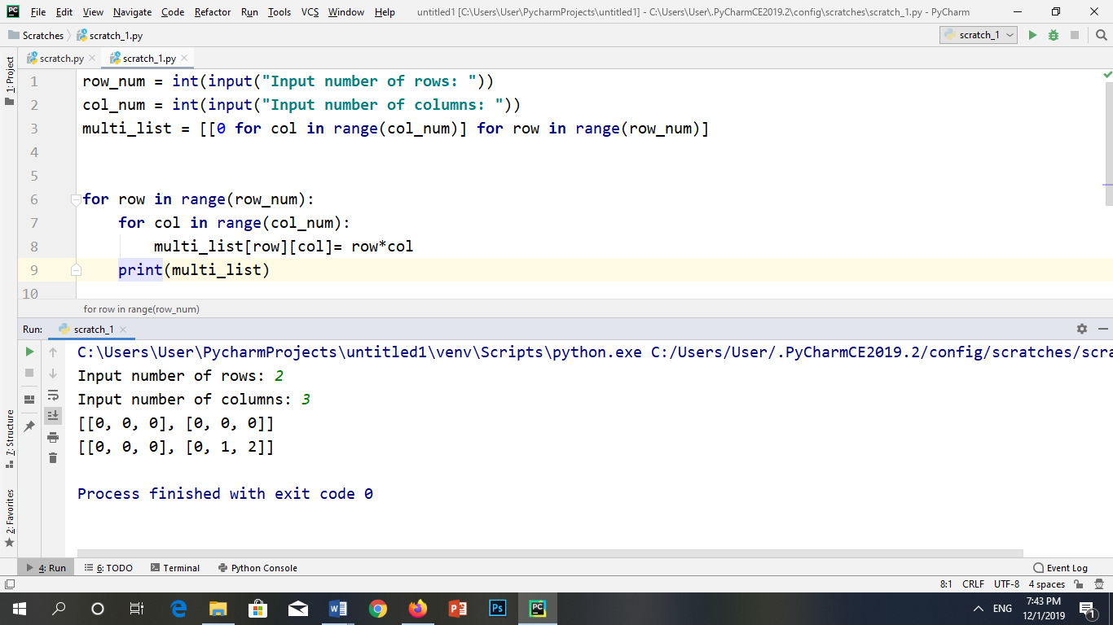

OUTPUT:



PROBLEM#7

Write a program which will check the data type of given data in a loop.

INPUT:

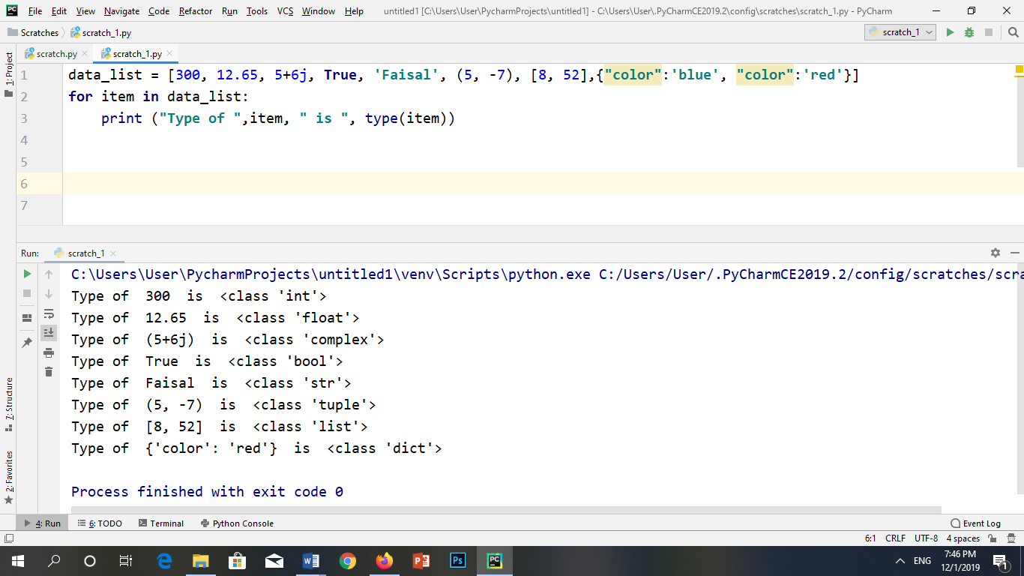

OUTPUT:



PROBLEM#8

Write a program to generate the ASCII Chart from 0 to 256.

INPUT:

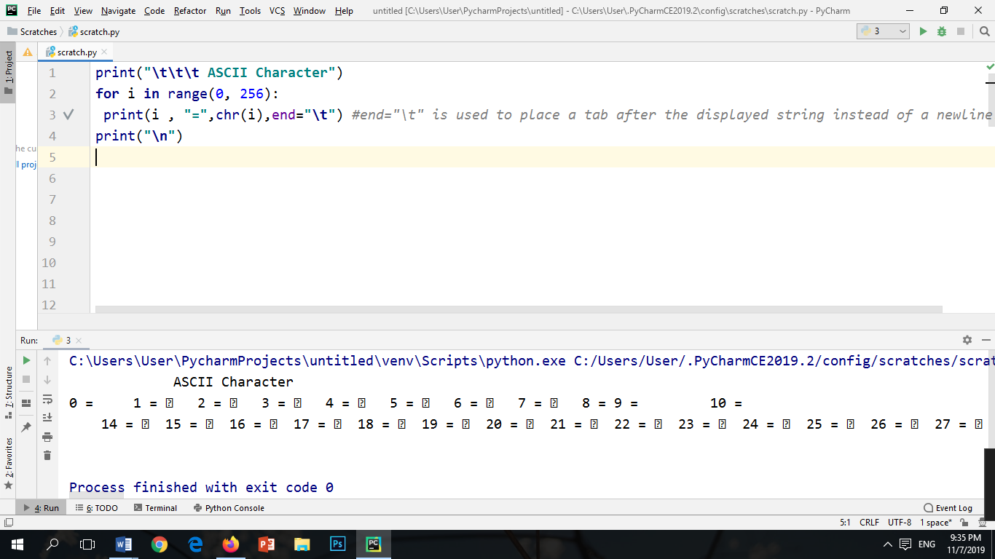

OUTPUT:



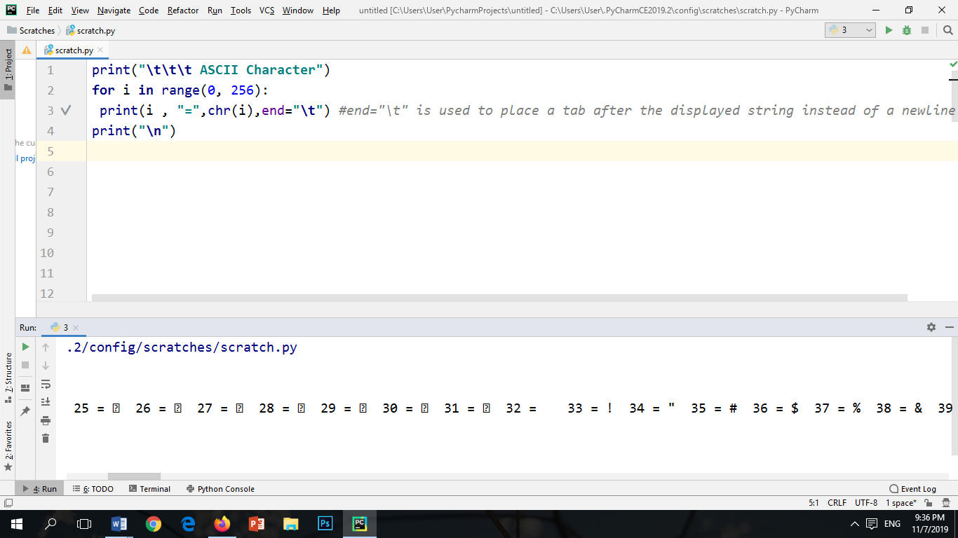

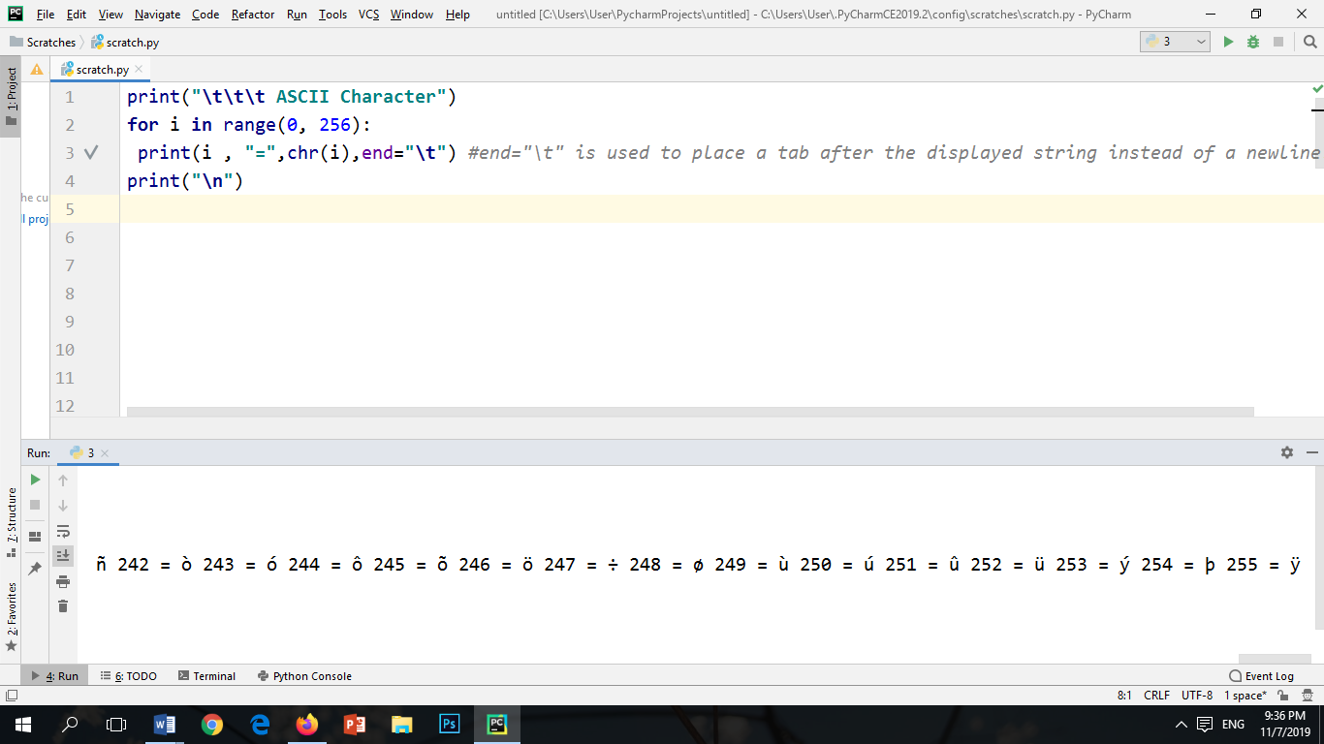

PROBLEM#9

Write a program to convert digital number from 0 to 16 into binary, octal and hexa-decimal number system.

INPUT:

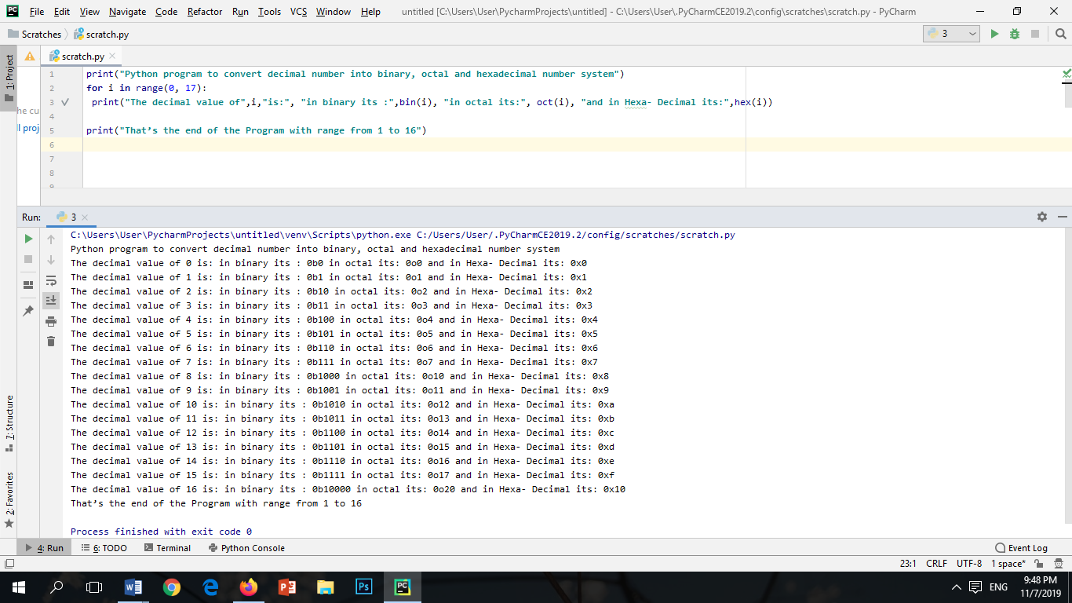

OUTPUT:



PROBLEM#10

Write a Python program to construct the following pattern, using a nested for loop.

INPUT:

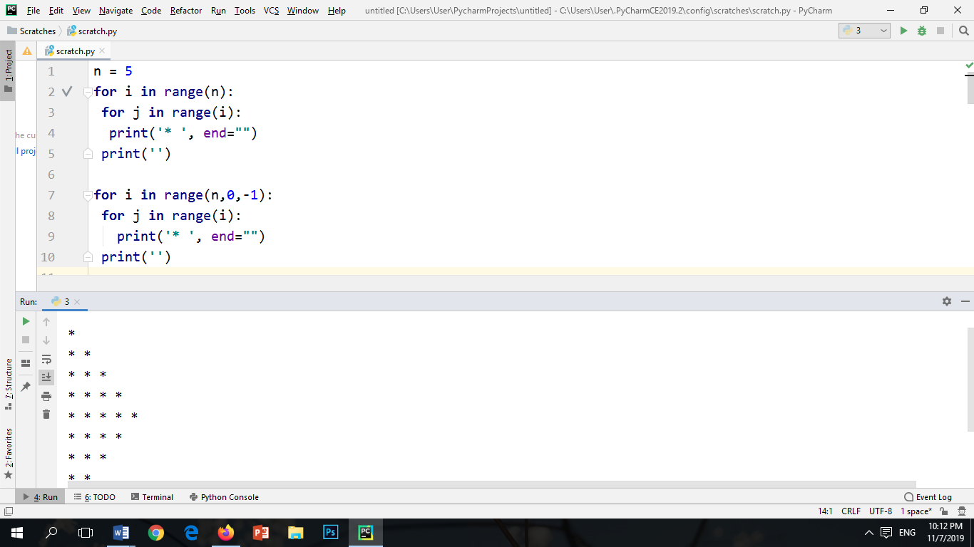

OUTPUT:

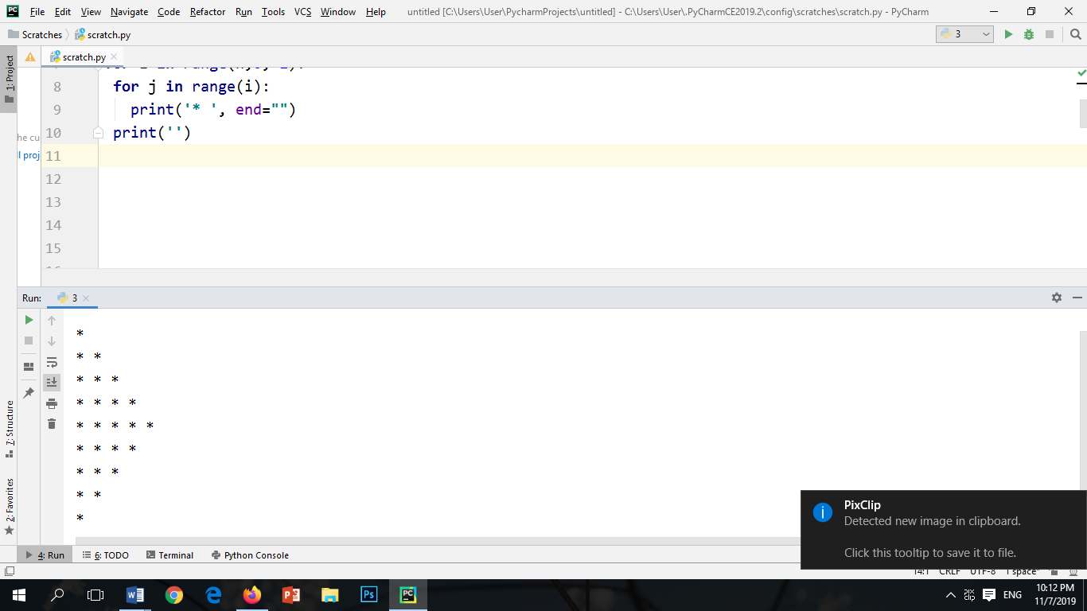

PROBLEM#11

Write a program which calculates the vowels from the given string.

INPUT:

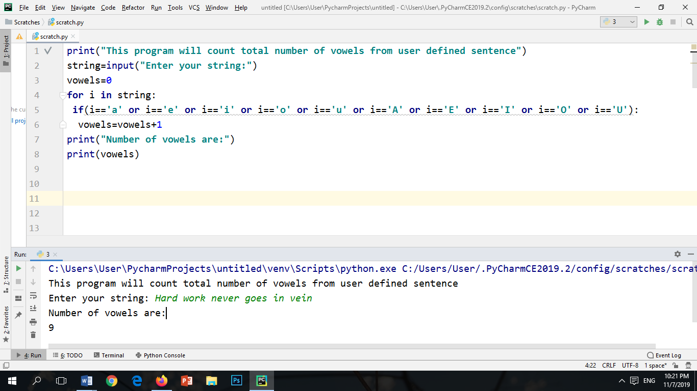

OUTPUT:



**Programming Exercise**

Question#1

1. Write a program which solves the quadratic equation. The user will enter the value of a, b ,c. The program will then check the denominator that if denominator is zero or not. If its zero it can reply the equation cannot solve as there is a zero division else, it will execute the program and will generate two solutions.

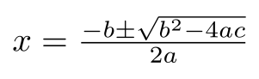

INPUT:

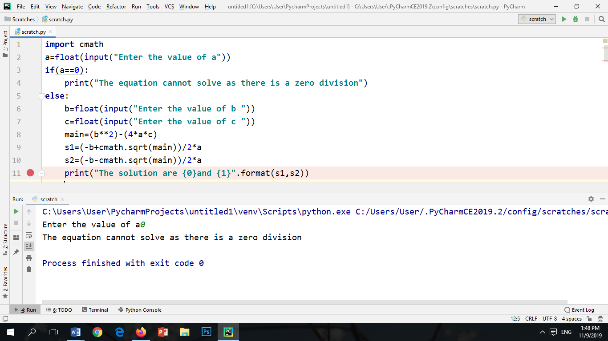

OUTPUT:

When a=0



When a!=0

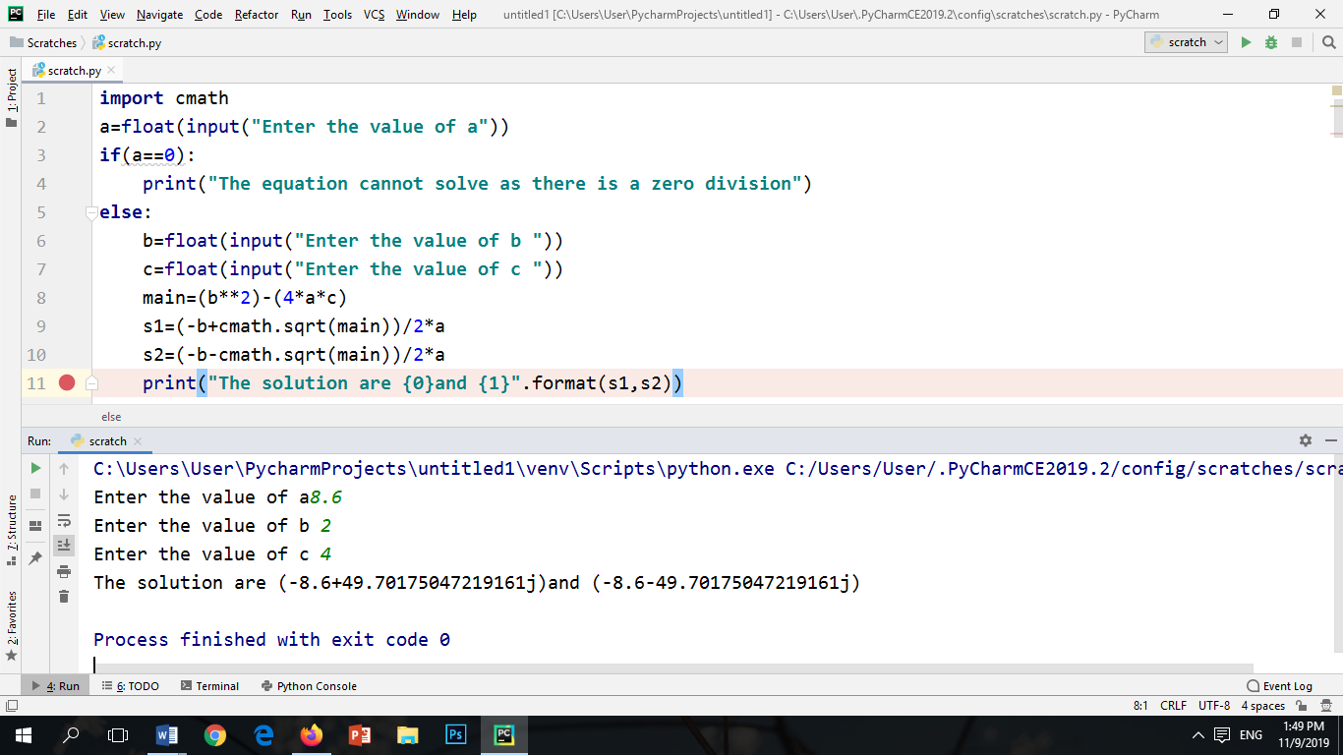

Question#2

Calculate the arithmetic sequence of n numbers. The program will generate the nth term of the sequence, whereas the user will enter the first term and the common difference. The program will then ask either to continue or not, if the user will enter yes it will ask the next nth term to calculate.

INPUT:

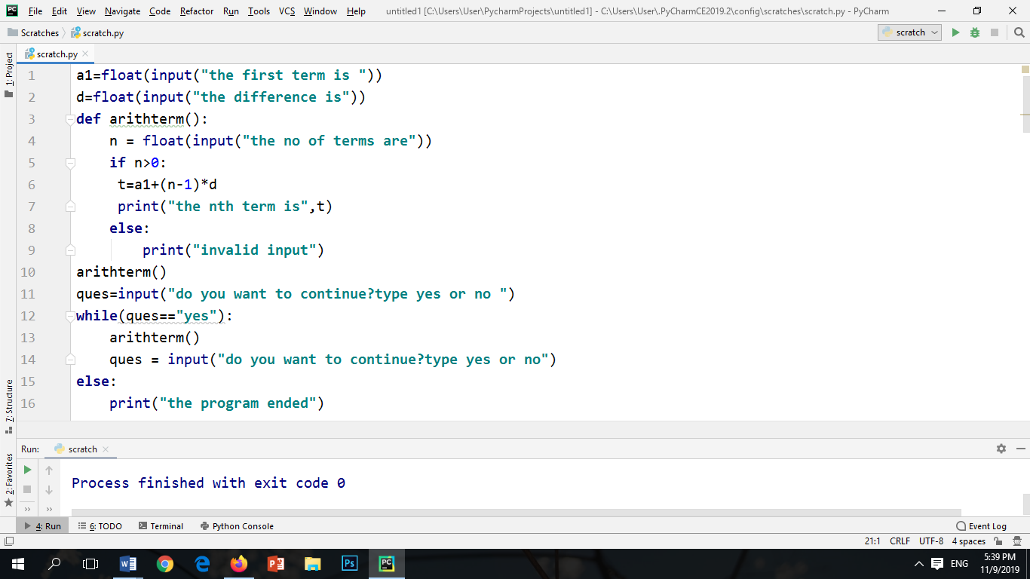

OUTPUT:

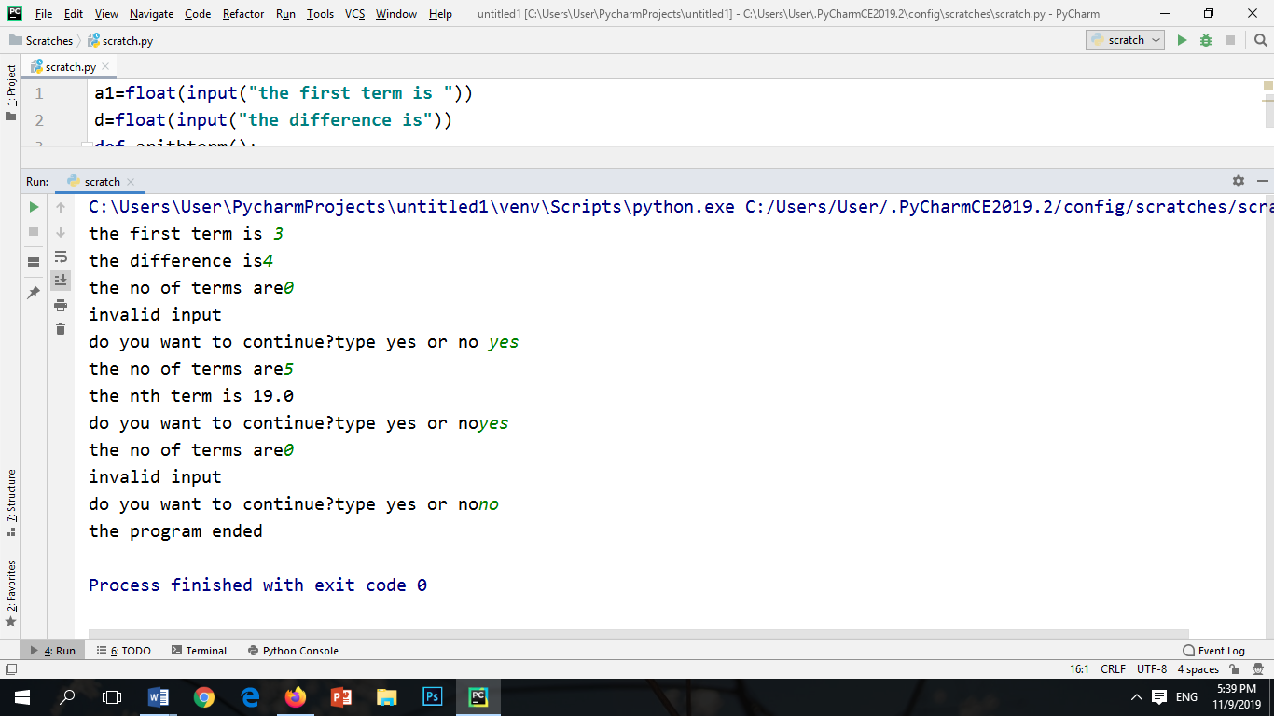

Question#3

Write a program which will check either the giving string is Palindrome or not. Palindrome is a string when we reverse the string it will generate the original string. Example CIVIC, MOM, 010,1001, etc. So if you enter the word which is Palindrome it will say yes your string is Palindrome otherwise it will generate sorry message.

INPUT:

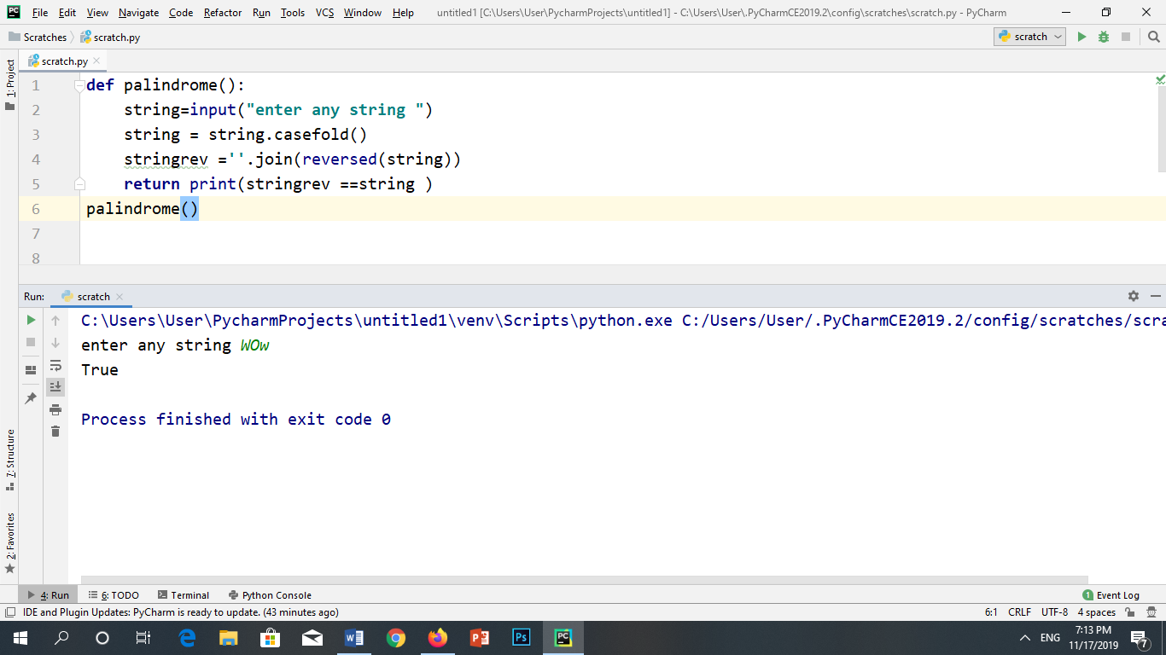

OUTPUT:



4. Write a program which will collect your name, your father’s name, your roll number and your subjects (5 Subjects with name and numbers). At the end it will generate a result with your name, your father’s name, your details subjects, marks you have obtained with total marks with grade and percentage.